**CRF 114639**

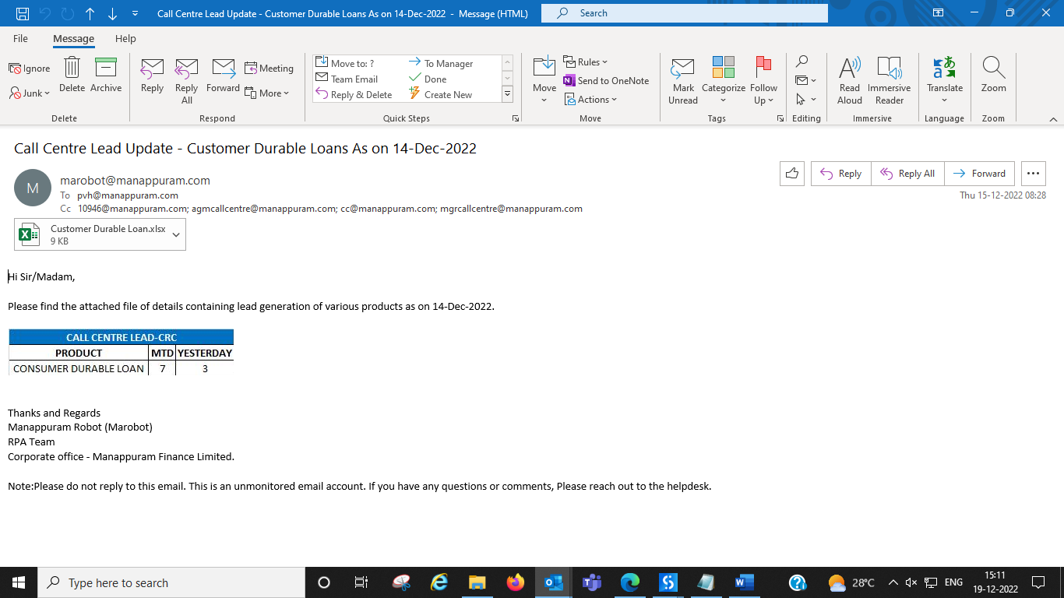

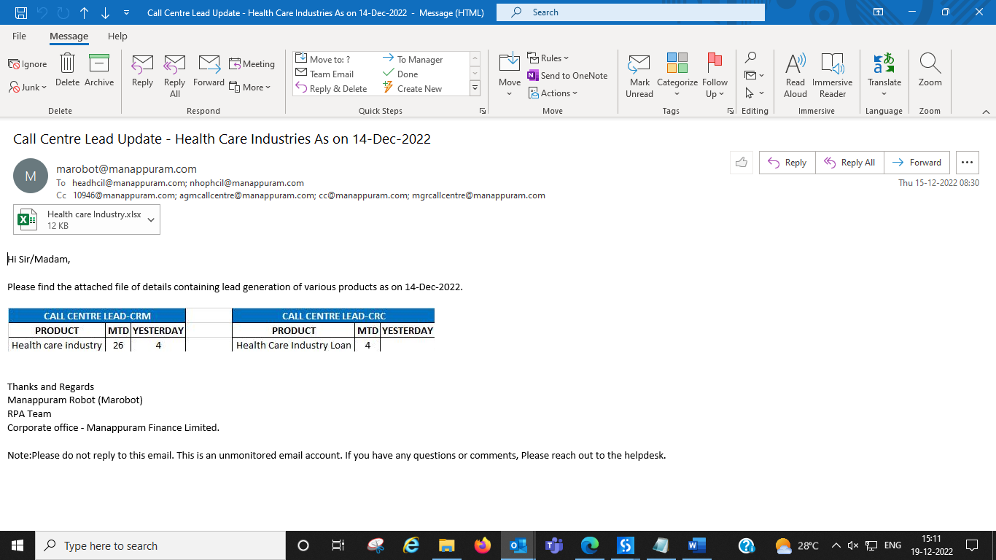

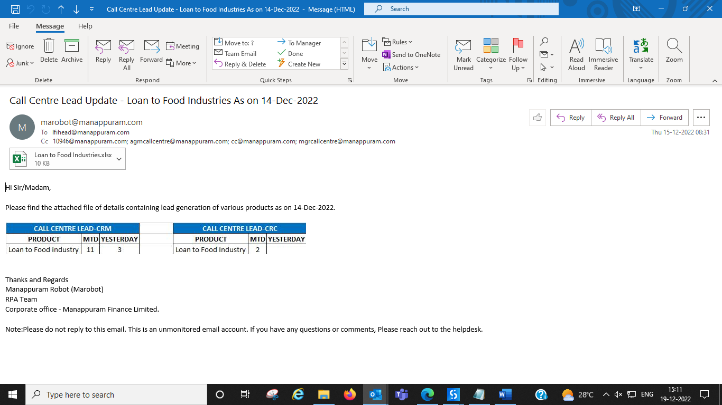

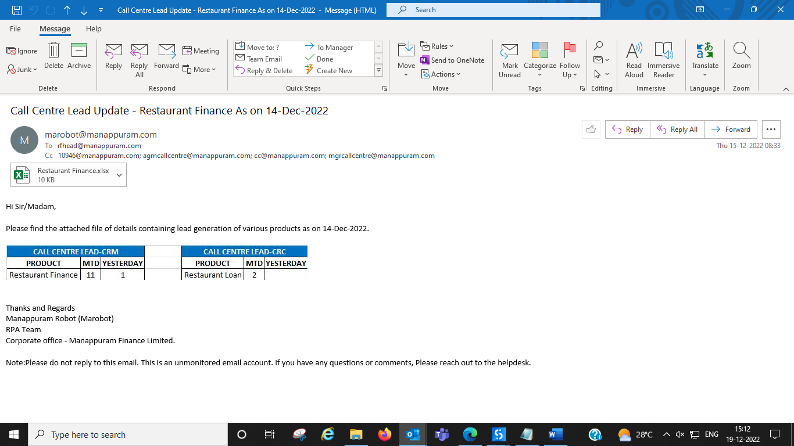

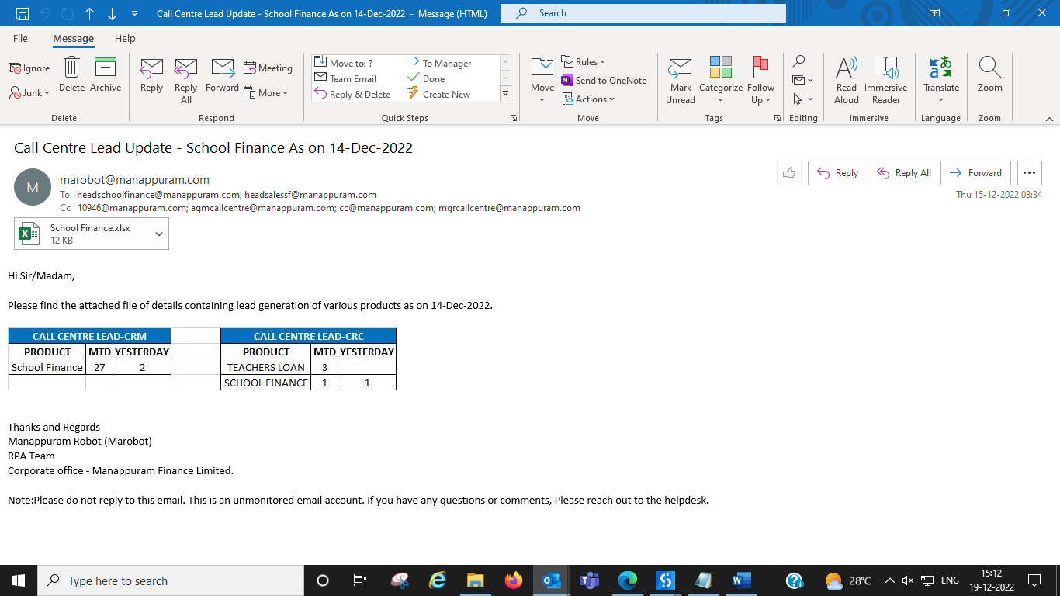

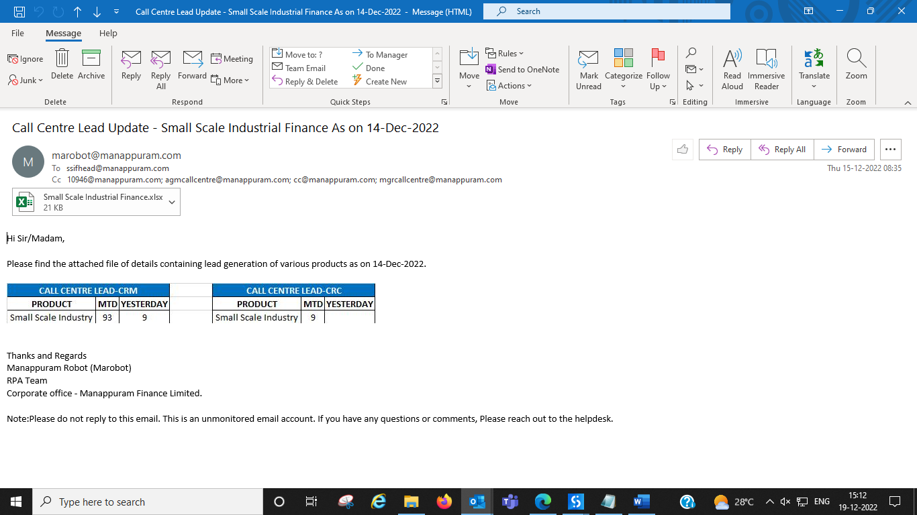

**Excel Data**

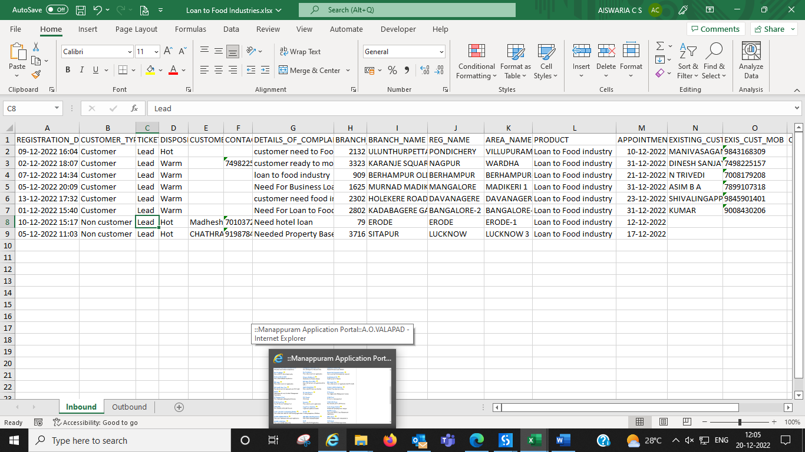

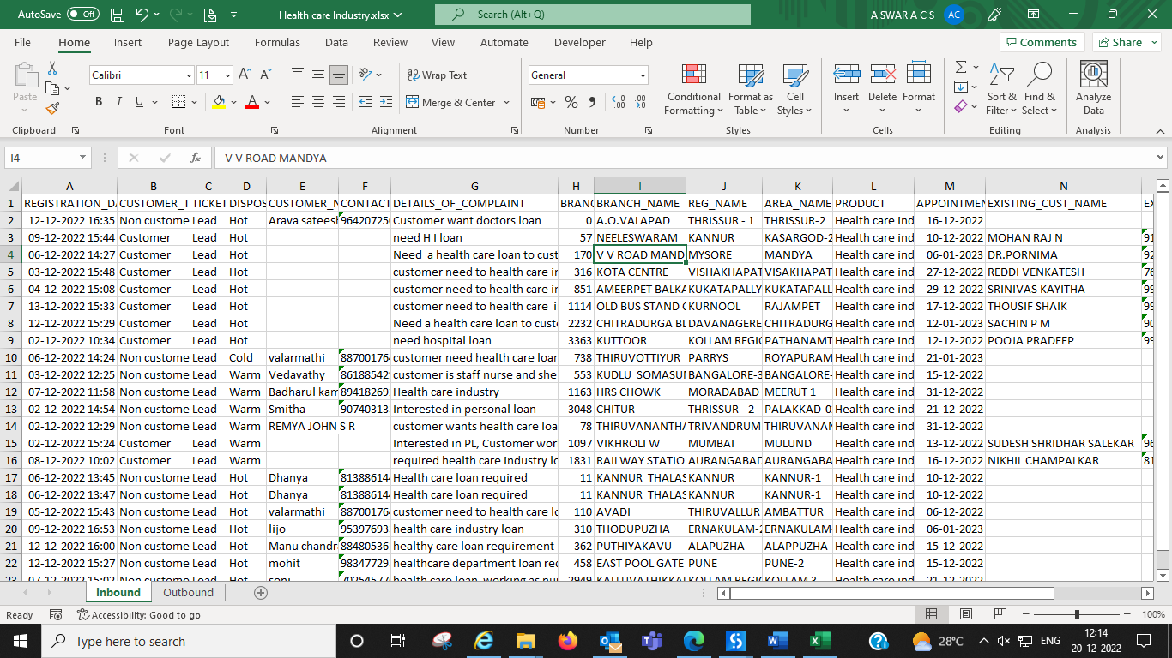

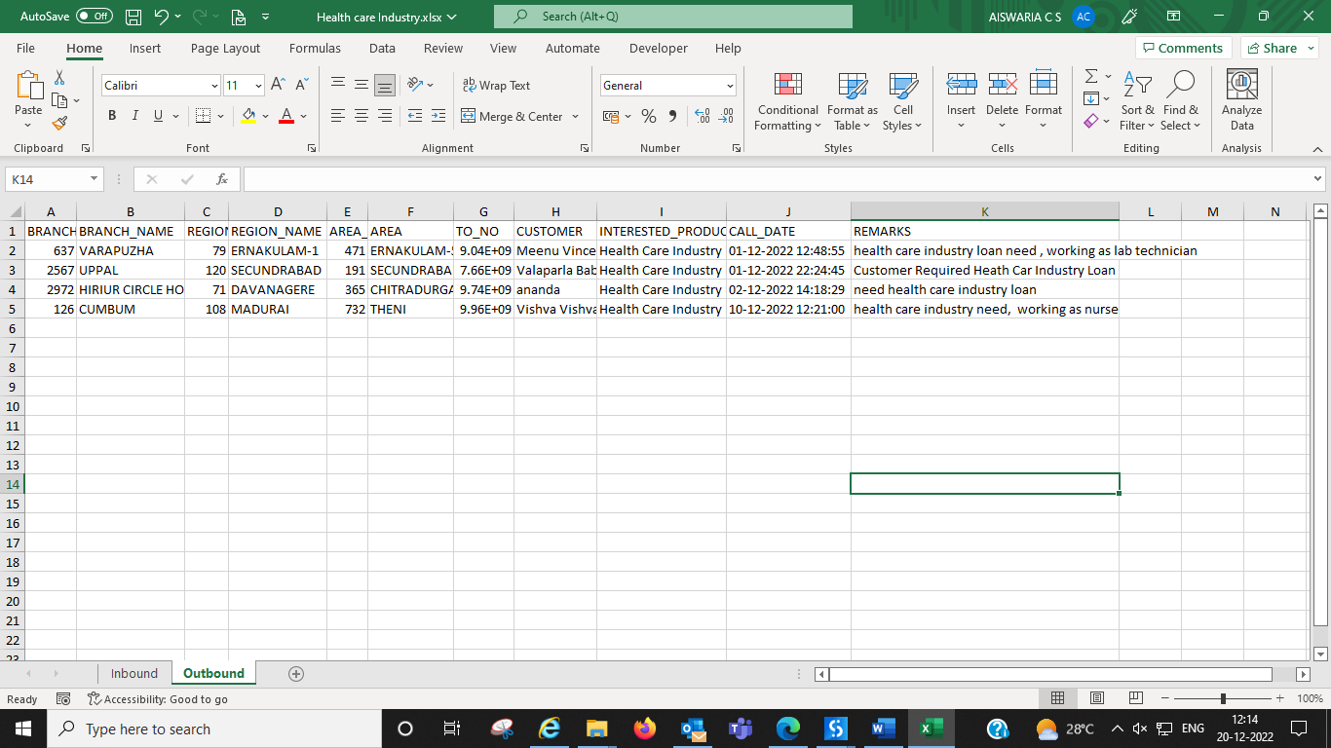

**Queries**

***1.CRM MTD***

select row_number() over(order by x.followup_id) as SlNo,

x.fzm_id,

x.fzm,

x.reg_id as Region_ID,

x.reg_name as Region_name,

x.area_id as Area_ID,

x.area_name as Area,

x.branch_id,

x.branch_name,

x.did_no as From_did,

x.initial_mobile_no as To_no,

case

when x.initial_mobile_no = x.mobile then

'NIL'

else

to_char(x.mobile)

end as Alternate_number,

x.cust_name as Customer,

x.leadsource_name as Lead_Source,

x.products_name as Interested_Product,

x.emp_code as Emp_Code,

x.emp_name as Employee_Name,

x.col_language as Group_lang,

(x.inserted_on) as Call_Date,

x.lead_date as Lead_date,

(x.call_response_id) as Disposition,

x.intrested_status as Status,

x.response as Call_Response,

x.call_duration as Duration,

x.process as Process,

x.call_center_comment as Remarks,

x.pledge_weight as Pledge_Weight,

x.pledge_amount as Pledge_Amount

from (select distinct f.followup_id,

g.fzm_id,

g.fzm,

d.branch_id,

d.branch_name,

d.reg_id,

d.reg_name,

d.area_id,

d.area_name,

e.did_no,

f.initial_mobile_no,

f.mobile,

t.cust_name,

c.leadsource_name,

p.products_name,

f.emp_code,

e.emp_name,

b.col_language,

to_char(f.inserted_on, 'DD-MM-YYYY HH24:Mi:SS') inserted_on,

decode(f.call_status, 1, 'ANSWERED', 0, 'NO ANSWER',2,'BUSY',3,'FAILED',null,'FAILED') call_response_id,

decode(f.intrested_status,

1,

'INTERESTED',

2,

'NOT INTERESTED',3,'call back') intrested_status,

decode(f.call_response_id,

1,

'ANSWERED',

2,

'NOT ATTENTED',

3,

'NOT REACHABLE',

4,

'SWITCHED OFF',

5,

'NOT REACHABLE',

7,

'INCOMING CALL') response,

f.call_duration call_duration,

decode(f.process, 1, 'Incoming', 2, 'Outgoing') process,

t.lead_date,

f.call_center_comment,

t.pledge_weight,

t.pledge_amount

from mana0809.tbl_crc_mst t, mana0809.tbl_crc_followup_dtl f

left join mana0809.tbl_crc_products p

on p.products_id = f.interested_products_id,

mana0809.tbl_leadsource_category c, mana0809.tbl_crc_emp_dtls e,

mana0809.tbl_crc_bucket_emp_dtl b, mana0809.branch_dtl_new d,

mana0809.tbl_fzm_master g

where t.lead_id = f.lead_id

and f.emp_code = e.emp_code

and b.bucket_id = t.bucket_id

and t.followup_status = 1

and t.branch_id = d.branch_id

and c.leadsource_id = t.lead_source_cat

and t.lead_source_cat = 8

and d.reg_id = g.region_id

and trunc(t.lead_date) = trunc(f.inserted_on) and f.intrested_status=1 and p.products_id not in (1,22,25,26) and p.products_id is not null

and trunc(f.inserted_on) between to_date(last_day(add_months(SYSDATE-1, -1)) + 1) and to_date(sysdate)-1

order by inserted_on) x

***2.CRC MTD***

select y.products_name interested_product,count(y.initial_mobile_no) cnt from(select

x.fzm_id,

x.fzm,

x.reg_id as Region_ID,

x.reg_name as Region_name,

x.area_id as Area_ID,

x.area_name as Area,

x.branch_id,

x.branch_name,

x.did_no as From_no,

x.initial_mobile_no,

case

when x.initial_mobile_no = x.mobile then

'NIL'

else

to_char(x.mobile)

end as Alternate_number,

x.cust_name as Customer,

x.leadsource_name as Lead_Source,

x.products_name ,

x.emp_code as Emp_Code,

x.emp_name as Employee_Name,

x.col_language as Group_lang,

(x.inserted_on) as Call_Date,

x.lead_date as Lead_date,

(x.call_response_id) as Disposition,

x.intrested_status as Status,

x.response as Call_Response,

x.call_duration as Duration,

x.process as Process,

x.call_center_comment as Remarks,

x.pledge_weight as Pledge_Weight,

x.pledge_amount as Pledge_Amount

from (select distinct f.followup_id,

g.fzm_id,

g.fzm,

d.branch_id,

d.branch_name,

d.reg_id,

d.reg_name,

d.area_id,

d.area_name,

e.did_no,

f.initial_mobile_no,

f.mobile,

t.cust_name,

c.leadsource_name,

p.products_name,

f.emp_code,

e.emp_name,

b.col_language,

to_char(f.inserted_on, 'DD-MM-YYYY HH24:Mi:SS') inserted_on,

decode(f.call_status, 1, 'ANSWERED', 0, 'NO ANSWER',2,'BUSY',3,'FAILED',null,'FAILED') call_response_id,

decode(f.intrested_status,

1,

'INTERESTED',

2,

'NOT INTERESTED',3,'call back') intrested_status,

decode(f.call_response_id,

1,

'ANSWERED',

2,

'NOT ATTENTED',

3,

'NOT REACHABLE',

4,

'SWITCHED OFF',

5,

'NOT REACHABLE',

7,

'INCOMING CALL') response,

f.call_duration call_duration,

decode(f.process, 1, 'Incoming', 2, 'Outgoing') process,

t.lead_date,

f.call_center_comment,

t.pledge_weight,

t.pledge_amount

from mana0809.tbl_crc_mst t, mana0809.tbl_crc_followup_dtl f

left join mana0809.tbl_crc_products p

on p.products_id = f.interested_products_id,

mana0809.tbl_leadsource_category c, mana0809.tbl_crc_emp_dtls e,

mana0809.tbl_crc_bucket_emp_dtl b, mana0809.branch_dtl_new d,

mana0809.tbl_fzm_master g

where t.lead_id = f.lead_id

and f.emp_code = e.emp_code

and b.bucket_id = t.bucket_id

and t.followup_status = 1

and t.branch_id = d.branch_id

and c.leadsource_id = t.lead_source_cat

and t.lead_source_cat = 8

and d.reg_id = g.region_id

and trunc(t.lead_date) = trunc(f.inserted_on) and f.intrested_status=1 and p.products_id not in (1,22,25,26) and p.products_id is not null

and trunc(f.inserted_on) between to_date(last_day(add_months(SYSDATE-1, -1)) + 1) and to_date(sysdate)-1

order by inserted_on) x)y group by y.products_name

***3.CRM Yesterday.***

select row_number() over(order by x.followup_id) as SlNo,

x.fzm_id,

x.fzm,

x.reg_id as Region_ID,

x.reg_name as Region_name,

x.area_id as Area_ID,

x.area_name as Area,

x.branch_id,

x.branch_name,

x.did_no as From_did,

x.initial_mobile_no as To_no,

case

when x.initial_mobile_no = x.mobile then

'NIL'

else

to_char(x.mobile)

end as Alternate_number,

x.cust_name as Customer,

x.leadsource_name as Lead_Source,

x.products_name as Interested_Product,

x.emp_code as Emp_Code,

x.emp_name as Employee_Name,

x.col_language as Group_lang,

(x.inserted_on) as Call_Date,

x.lead_date as Lead_date,

(x.call_response_id) as Disposition,

x.intrested_status as Status,

x.response as Call_Response,

x.call_duration as Duration,

x.process as Process,

x.call_center_comment as Remarks,

x.pledge_weight as Pledge_Weight,

x.pledge_amount as Pledge_Amount

from (select distinct f.followup_id,

g.fzm_id,

g.fzm,

d.branch_id,

d.branch_name,

d.reg_id,

d.reg_name,

d.area_id,

d.area_name,

e.did_no,

f.initial_mobile_no,

f.mobile,

t.cust_name,

c.leadsource_name,

p.products_name,

f.emp_code,

e.emp_name,

b.col_language,

to_char(f.inserted_on, 'DD-MM-YYYY HH24:Mi:SS') inserted_on,

decode(f.call_status, 1, 'ANSWERED', 0, 'NO ANSWER',2,'BUSY',3,'FAILED',null,'FAILED') call_response_id,

decode(f.intrested_status,

1,

'INTERESTED',

2,

'NOT INTERESTED',3,'call back') intrested_status,

decode(f.call_response_id,

1,

'ANSWERED',

2,

'NOT ATTENTED',

3,

'NOT REACHABLE',

4,

'SWITCHED OFF',

5,

'NOT REACHABLE',

7,

'INCOMING CALL') response,

f.call_duration call_duration,

decode(f.process, 1, 'Incoming', 2, 'Outgoing') process,

t.lead_date,

f.call_center_comment,

t.pledge_weight,

t.pledge_amount

from mana0809.tbl_crc_mst t, mana0809.tbl_crc_followup_dtl f

left join mana0809.tbl_crc_products p

on p.products_id = f.interested_products_id,

mana0809.tbl_leadsource_category c, mana0809.tbl_crc_emp_dtls e,

mana0809.tbl_crc_bucket_emp_dtl b, mana0809.branch_dtl_new d,

mana0809.tbl_fzm_master g

where t.lead_id = f.lead_id

and f.emp_code = e.emp_code

and b.bucket_id = t.bucket_id

and t.followup_status = 1

and t.branch_id = d.branch_id

and c.leadsource_id = t.lead_source_cat

and t.lead_source_cat = 8

and d.reg_id = g.region_id

and trunc(t.lead_date) = trunc(f.inserted_on) and f.intrested_status=1 and p.products_id not in (1,22,25,26) and p.products_id is not null

and trunc(f.inserted_on) = to_date(sysdate)-1

order by inserted_on) x

***4.CRC Yesterday***

select y.products_name interested_product,count(y.initial_mobile_no) cnt from(select

x.fzm_id,

x.fzm,

x.reg_id as Region_ID,

x.reg_name as Region_name,

x.area_id as Area_ID,

x.area_name as Area,

x.branch_id,

x.branch_name,

x.did_no as From_no,

x.initial_mobile_no,

case

when x.initial_mobile_no = x.mobile then

'NIL'

else

to_char(x.mobile)

end as Alternate_number,

x.cust_name as Customer,

x.leadsource_name as Lead_Source,

x.products_name ,

x.emp_code as Emp_Code,

x.emp_name as Employee_Name,

x.col_language as Group_lang,

(x.inserted_on) as Call_Date,

x.lead_date as Lead_date,

(x.call_response_id) as Disposition,

x.intrested_status as Status,

x.response as Call_Response,

x.call_duration as Duration,

x.process as Process,

x.call_center_comment as Remarks,

x.pledge_weight as Pledge_Weight,

x.pledge_amount as Pledge_Amount

from (select distinct f.followup_id,

g.fzm_id,

g.fzm,

d.branch_id,

d.branch_name,

d.reg_id,

d.reg_name,

d.area_id,

d.area_name,

e.did_no,

f.initial_mobile_no,

f.mobile,

t.cust_name,

c.leadsource_name,

p.products_name,

f.emp_code,

e.emp_name,

b.col_language,

to_char(f.inserted_on, 'DD-MM-YYYY HH24:Mi:SS') inserted_on,

decode(f.call_status, 1, 'ANSWERED', 0, 'NO ANSWER',2,'BUSY',3,'FAILED',null,'FAILED') call_response_id,

decode(f.intrested_status,

1,

'INTERESTED',

2,

'NOT INTERESTED',3,'call back') intrested_status,

decode(f.call_response_id,

1,

'ANSWERED',

2,

'NOT ATTENTED',

3,

'NOT REACHABLE',

4,

'SWITCHED OFF',

5,

'NOT REACHABLE',

7,

'INCOMING CALL') response,

f.call_duration call_duration,

decode(f.process, 1, 'Incoming', 2, 'Outgoing') process,

t.lead_date,

f.call_center_comment,

t.pledge_weight,

t.pledge_amount

from mana0809.tbl_crc_mst t, mana0809.tbl_crc_followup_dtl f

left join mana0809.tbl_crc_products p

on p.products_id = f.interested_products_id,

mana0809.tbl_leadsource_category c, mana0809.tbl_crc_emp_dtls e,

mana0809.tbl_crc_bucket_emp_dtl b, mana0809.branch_dtl_new d,

mana0809.tbl_fzm_master g

where t.lead_id = f.lead_id

and f.emp_code = e.emp_code

and b.bucket_id = t.bucket_id

and t.followup_status = 1

and t.branch_id = d.branch_id

and c.leadsource_id = t.lead_source_cat

and t.lead_source_cat = 8

and d.reg_id = g.region_id

and trunc(t.lead_date) = trunc(f.inserted_on) and f.intrested_status=1 and p.products_id not in (1,22,25,26) and p.products_id is not null

and trunc(f.inserted_on) = to_date(sysdate)-1

order by inserted_on) x)y group by y.products_name